Schedule A – NCU Marketing Creative and Content Guidelines

General

Northcentral University: Online Graduate Education at a Higher Degree

Northcentral University was founded to provide accessible, high-quality, online graduate degrees to working professionals. As a regionally accredited, online university, NCU serves students worldwide, focusing on Doctoral and Master’s degree programs in the Schools of Business and Technology Management, Education, Psychology and Marriage and Family Sciences. NCU utilizes a One-to-One Teaching Model—one student paired with a member of NCU’s 100% doctoral faculty in each course— to create a more personalized education experience for adult students who share a passion for excellence in higher education.

Northcentral University: Online Graduate Education at a Higher Degree

Northcentral University is a regionally accredited university delivering online Master’s and Doctoral degree programs in business, education, psychology and marriage and family therapy to working professionals around the world. Advance to a higher degree with NCU and enhance your ability to solve problems, think critically and reflectively, conduct research, and communicate effectively in today’s diverse global environment. Find out what over 9,000 students—and thousands of successful alumni already know—Northcentral University works for working professionals.

Doctoral

When you decide to pursue your doctorate at Northcentral University, you are joining an international community of scholars committed to academic excellence. As one of the first graduate-focused, regionally accredited, online universities in the U.S., Northcentral is particularly suited to busy adult students and working professionals, like you, who are looking for an online doctoral degree program that can help you achieve your goals while maintaining your busy schedule. Northcentral provides both PhD and professional doctoral programs in Business, Education, Psychology and Marriage and Family Therapy, along with a dedicated support system to help guide you toward graduation as you make a successful transition from doctoral student to independent scholar.

Master’s

Northcentral University offers online master’s degree programs in business, education, psychology and marriage and family therapy that can help you develop the skills and knowledge to lead others within your organization and make a positive difference in your field. In our master’s degree programs, you will apply leadership principles in your field to real-world problems and case studies. You will also work one-to-one with a member of our 100% doctoral faculty who share their own knowledge and experiences with you. With exciting specializations to choose from and accelerated track options to keep you on schedule to reach your goals even faster, Northcentral University provides you with the quality and flexibility you need to advance your education and achieve your personal and professional goals.

Bachelor’s Completion

Completing your bachelor’s degree just got more convenient. Northcentral University offers online bachelor’s degree-completion programs in business and psychology that combine personalized instruction from highly credentialed faculty with quality programs and enhanced accessibility. Northcentral utilizes a distinctive one-to-one teaching model that pairs you with a member of our 100% doctoral faculty for each course. This creates a more personalized learning experience that ensures you receive the feedback and support needed to be successful. This is your opportunity to complete your undergraduate education at a regionally accredited, online university, with a simplified application process and the flexibility you need to make it work.
International

Northcentral University: Meeting a Global Need for Quality Online Graduate Education
Northcentral University is a U.S. regionally accredited university with a focus on delivering online Master’s and Doctoral degree programs in business, education, psychology and marriage and family therapy to students and working professionals around the world. As an international community of scholars, we value diversity of thought and action as a strength that allows our academic community to rise above organizational and geographic boundaries. Our One-to-One teaching model provides you the opportunity to work individually with a member of our 100% doctoral faculty in each of your courses for a personalized learning experience designed to encourage professional application. With no physical residency requirements, you can be a part of the NCU learning community regardless of your geographic location, as long as you have access to the Internet and fulfill our admissions requirements.
Military

Advance to a Higher Degree with Northcentral University
At Northcentral University, we take tremendous pride in our unique ability to meet the educational needs of active duty military, veterans, reservists, guardsmen and their benefit-eligible family members. We currently serve more than 2,000 current military students, and our online degree programs in business, education, psychology and marriage and family therapy, provide an efficient and practical way for you to continue your education wherever military life takes you. This is your opportunity to get ahead, so when the time comes, you’ll be ready for the next phase of your career—whether you remain in the military or transition to the private sector.

School of Business and Technology Management

As a business professional, you need to be at the top of your game. Northcentral University is regionally accredited and delivers online undergraduate and graduate degrees in business to help you gain the knowledge, skills and competencies needed to become a more effective leader with the business acumen required by today’s companies and clients. Northcentral’s School of Business and Technology Management offers ACBSP-accredited bachelor’s completion, master’s and doctoral programs in business, with 18 unique specializations that allow you tailor your education to your professional goals.
School of Education

As educators, we all want to see our students succeed. For Northcentral University, that means providing the quality education you need to become a more effective educator, researcher or administrator in your field. Northcentral’s School of Education delivers online bachelor’s completion, master’s, certificate, specialist and doctoral programs, with focused specializations that allow you tailor your education to your personal and professional interests. We understand that the pedagogy of educating adult learners is unique and has its own concepts and challenges, which is why we’ve adopted a One-to-One teaching model that partners you with a member of our 100% doctoral faculty in each of your courses. This way, you receive personalized attention and feedback, along with the flexibility and support you need to advance your education online and achieve your goals.
School of Psychology

Northcentral University’s School of Psychology offers programs at the bachelor’s, master’s and doctoral level that are designed to refine your critical thinking, writing and research skills in order to analyze psychological principles and apply them to personal, social and organizational issues. As part of our One-to-One faculty mentored approach to online learning, you will partner with a member of our 100% doctoral faculty for each course to ensure you receive the support and professional feedback necessary to grow within your program, achieve your academic goals, and continue your contributions to your community and profession.

School of Marriage and Family Sciences

If you are interested in joining the rewarding field of Marriage and Family Therapy (MFT), Northcentral University’s School of Marriage and Family Sciences can provide you with an online, Marriage and Family Therapy graduate degree to help prepare you to become a competent, ethical and culturally sensitive marriage and family therapist. Our MFT faculty hold doctoral degrees and are practicing therapists who will engage you in a One-to-One process. This process invites professional and personal growth through the development of critical thinking skills, information literacy, important clinical skills, an appreciation of research, a valuing of diversity, and a lifelong commitment to learning and service.

WHY NORTHCENTRAL?
Regionally accredited
One-to-One faculty mentored approach
No physical residency requirements
Highly credentialed faculty
Applied experiential learning
Weekly course starts
Every course can be started any week
Competitive tuition
100% doctoral faculty to the list of NCU value propositions

QUICK FACTS
- The Society for Human Resource Management (SHRM) has acknowledged that Northcentral University’s Bachelor and Master of Business Administration/Human Resource Specialization fully aligns with SHRM’s HR Curriculum Guidebook and Templates.
- Northcentral University is recognized as a Registered Education Provider (R.E.P.) at the Global Provider Enrollment Level by Project Management Institute (PMI)®. {Registered trademark must appear.}

MISSION, VISION AND VALUES

MISSION
Northcentral University educates professionals throughout the world and provides an accessible opportunity to earn a U.S. regionally accredited degree. Northcentral mentors students One-to-One with highly credentialed faculty via advanced delivery modalities. Northcentral commits to helping students achieve academically and become valuable contributors to their communities and within their professions.

VISION
Northcentral University is a premier online graduate university and a global leader in providing unprecedented access to U.S. regionally accredited higher education.

VALUES: I.D.E.A.'s Founded on INTEGRITY
We hold all members of our community to the highest ethical standards of professional and academic conduct and the rules and regulations of U.S. higher education.

Innovation: We envision new and innovative education delivery systems, and support proven concepts of teaching and learning. We encourage our community to seek solutions to educational challenges that will improve the quality of our programs and services.

Diversity: We value diversity of thought and action as a strength that allows our community to transcend organizational and geographical boundaries. We expect members of our community to treat people with respect and dignity.

Excellence: Our community is committed to excellence in academics and service. We value leadership and strive for continuous improvement in everything we do. We define and measure outcomes and take action to ensure that our community’s passion for excellence is never compromised.

Accountability: We are deeply committed to holding each member of the University responsible for their scholarly and professional work. We expect financial responsibility in the actions of our students and University team.

------------------------------------------------------------------------------------------------------------------------------------------

REQUIRED ON ALL NCU LANDING PAGES, FACTSHEETS AND/OR MICROSITES
Northcentral University is regionally accredited by the Higher Learning Commission of the North Central Association of Colleges and Schools (HLC). (230 South LaSalle Street, Suite 7-500, Chicago, IL 60604, 1.800.621.7440, www.ncahlc.org).
Northcentral University strives to enable students to make informed choices about their academic program selection by making disclosures to prospective students in a clear, timely, and meaningful way. Visit www.ncu.edu/GE for more information.
Active programs and specializations may vary. Please contact NCU for current program and specialization offerings.

By clicking submitting this form, I acknowledge that I may be contacted by email, text message and/or phone at the number provided above, including my wireless number, if provided, by a representative of NCU.

Accreditation
Northcentral University is regionally accredited by the Higher Learning Commission of the North Central Association of Colleges and Schools (HLC). (230 South LaSalle Street, Suite 7-500, Chicago, IL 60604, 1.800.621.7440,www.ncahlc.org).

Disclaimer Statement: The Northcentral University Master of Education Program, which is designed to prepare professional educators to become effective leaders, reflective practitioners and successful communicators within the diverse field of education, centering on improving teaching, learning, research and leadership contributions throughout PK-12 Education, is granted Initial Accreditation by the Teacher Education Accreditation Council (TEAC) for a period of five years, from June 24, 2013 – June 24, 2018.This accreditation certifies that the forenamed professional education program has provided evidence that the program adheres to TEAC’s quality principles.

PROGRAMMATIC ACCREDITATION
- In addition to regional accreditation from the Higher Learning Commission (HLC), NCU’s degree programs in the School of Business and Technology Management are accredited by the Accreditation Council for Business Schools and Programs (ACBSP). NCU was the first accredited online university to feature an ACBSP accredited business school.

- The Master of Arts in Marriage and Family Therapy (MAMFT) degree program at NCU is the first program with distance education to receive the Commission on Accreditation for Marriage and Family Therapy Education’s (COAMFTE) coveted programmatic accreditation, ensuring that the University’s program aligns with national accreditation standards.
  - If referencing COAMFTE Accreditation the following language must be listed on the landing page, microsite or fact sheet:
The Master of Arts in Marriage and Family Therapy Program at Northcentral University is accredited by the Commission on Accreditation for Marriage and Family Therapy Education of the American Association for Marriage and Family Therapy, 112 South Alfred Street, Alexandria, Virginia 22314, Tel. No. (703) 838-9808.

- The Master of Education (MEd) PK-12 program at NCU has received initial five-year accreditation by the Teacher Education Accreditation Council (TEAC). TEAC accreditation certifies that Northcentral University has provided evidence that its MEd program adheres to TEAC’s quality principles and will support educational leadership for today’s PK-12 teachers through courses that are current and relevant to the field.
  - If referencing TEAC Accreditation the following language must be listed on the landing page, microsite or fact sheet:
The Northcentral University Master of Education Program, which is designed to prepare professional educators to become effective leaders, reflective practitioners and successful communicators within the diverse field of education, centering on improving teaching, learning, research and leadership contributions throughout PK-12 Education, is granted Initial Accreditation by the Teacher Education Accreditation Council (TEAC) for a period of five years, from 2013-2018.

DEGREE PROGRAM AND SPECIALIZATION SPECIFIC CONTENT
See www.ncu.edu or contact the NCU Marketing Team for additional degree program and specialization specific content outside of short and long program descriptions.

MULTIMEDIA CONTENT
Contact the NCU Marketing Team for approved multimedia content.

USE OF 100% ONLINE, COMPLETELY ONLINE AND/OR FULLY ONLINE
For the avoidance of doubt, use of the phrases 100% Online, Completely Online and/or Fully Online is approved only on content specific to degree programs and specializations under NCU’s School of Business and Technology Management.

USE OF GRANT OR SCHOLARSHIP BASED MESSAGING
Grant or scholarship focused copy and creative content (e.g. “You may qualify for a grant/scholarship”) used in the advertisement or promotional material is strictly prohibited without written authorization from Northcentral University.

REQUIRED DISCLAIMERS

Based on the copy and creative content, the following disclaimers must be incorporated into the advertisement or promotional materials or NCU cannot participate in the offer:
- Whenever program lengths are referenced, a disclaimer similar to the following must be visible to the consumer:
“Program lengths vary by institution”
- Whenever program outcomes or salaries are referenced, a disclaimer similar to the following must be visible to the consumer:
“Program outcomes and/or salaries are not guaranteed and vary according to each institutions specific curriculum”
- Whenever financial aid is referenced, a disclaimer similar to the following must be visible to the consumer:
“Financial aid may be available to those who qualify”
- If the education offer is placed in a co-registration path related to employment, a disclaimer similar to the following must be visible to the consumer:
“This is separate offer related to furthering your education and employment opportunities are not guaranteed.”
- If specific salary ranges are referenced, a reputable source of the info must be provided, preferably Bureau of Labor Statistics.

BANNED KEYWORDS, TERMS AND PHRASES
If any of the following keywords, terms or phrases are used in the advertisement or promotional material, NCU cannot participate in the offer:
- are guaranteed
- Cash back
- Contest
- does guarantee
- earn $
- earn a better salary
- earn a greater salary
- earn a handsome salary
- earn a median
- earn extra
- earn good money
- earn hefty
- earn money
- earn the highest
- earn-money
- Endorsed by
- Filling up fast
- Giveaway
- Guaranteed eligibility
- Guaranteed employment
- Guaranteed financial aid
- Guaranteed job
- Ipad
- Ipod
- is guaranteed
- Loans you do not have to repay
- out-earn
- President Obama
- Section 8
- Space is limited
- Stimulus package
- Sweepstakes
- Time is running out
- Unemployment
- Unemployment benefits
- Welfare
- Win

Northcentral Logo (Note: For electronic versions of any creative elements below, please contact Erin Walsh at ewalsh@ncu.edu)
With its emphasis on multiple colors coming together and interacting, this mark calls to mind the multifaceted nature of higher education: teacher-student interaction, diversity, the pursuit of learning and more. These elements combine to make the university experience what it is: unique and memorable. The two overlapping shapes on either side of the flame represent the one-to-one mentoring relationship between student and teacher. The flame in the center of the logo symbolizes the fire of enlightenment that education produces. The combination of the conceptual mark with traditional and modern typefaces produces a melding of the progressive and established.

Horizontal Color Logo 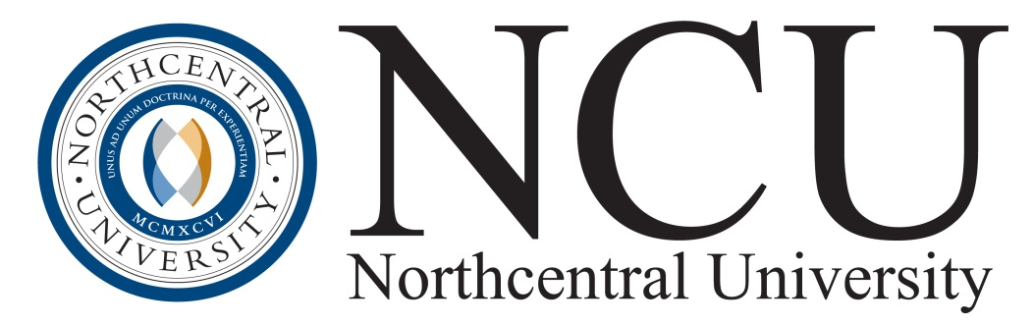
Horizontal Gray Logo 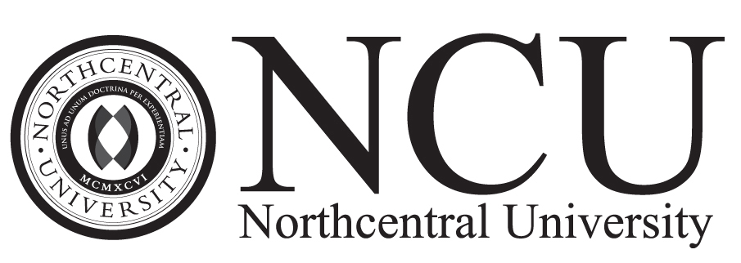
Seal Color Logo 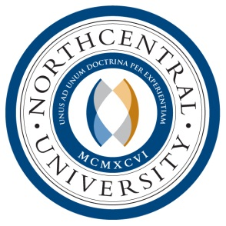
Seal Color Logo w/o Latin 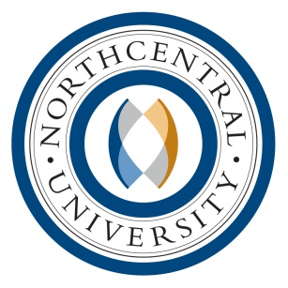

Vertical Gray Logo 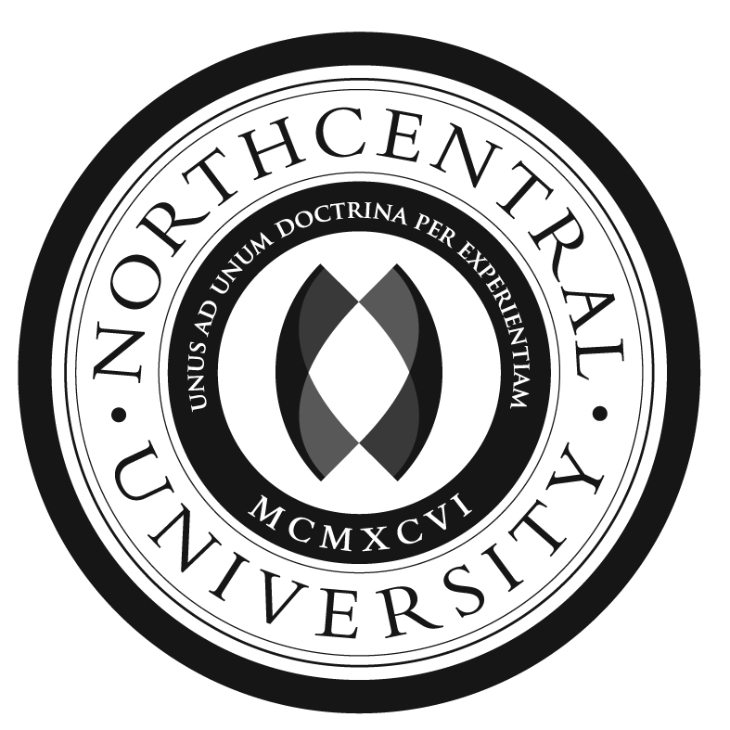
Seal Gray Logo w/o Latin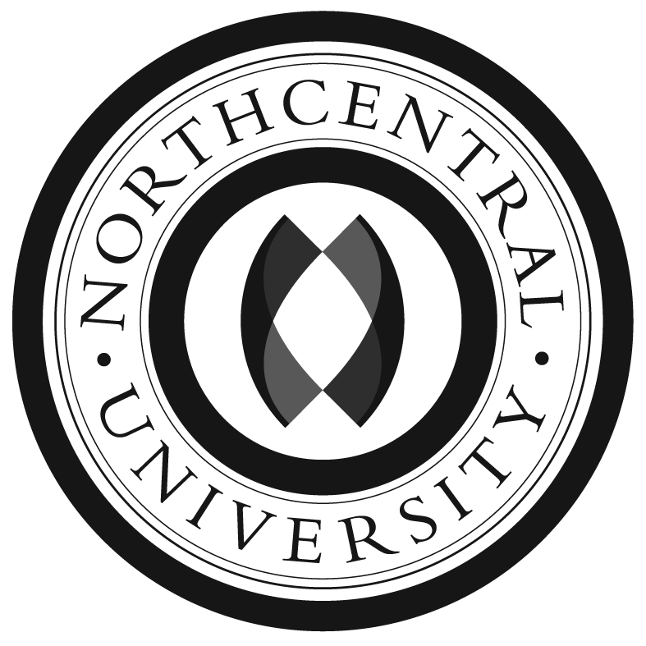
HEADERS



General color palette
The swatches below show the primary and secondary color palettes.
