Required Add = Red
Optional Add = Blue
Already Added = Green

IEC (Florida Career College)
Compliance Sheet

Marketing Partner: Rising Results Inc.
URL: http://www.topcollegedegrees.net/schools/campus/florida-career-college

- BRAND NAME: Florida Career College

- FIELDS:

- CAMPUSES & PROGRAMS:

  - ADD
    - UEI College – Phoenix – Update Acceptable Zip Codes

- CONTENT:

About Florida Career College
Florida Career College (FCC) is for individuals who seek to achieve more with their lives through education and training. No matter what stage of life you find yourself in, it is never too late to set new goals for yourself. Our students come from all walks of life. Some have just finished high school. Others are changing their careers, or want to get more skills for the one they have. Our students include new parents of all ages and parents whose kids are growing up. We have even seen parents and their children attending FCC together! At FCC, you’re treated like a person, not a number. We know that each student is different and faces different challenges. Our goal is to support them by delivering the education and training from skilled instructors, and providing supportive services they need to stay in school and succeed. So we help students who need services that range from tutoring to assistance with finding childcare, housing, and part-time jobs. We provide flexible class schedules that meet students’ busy schedules. Most of our programs are taught one class at a time to let students really focus on learning the material.

The Education Department
The Education department is dedicated to providing a quality education through career focused programming. In doing so, student services is an important part of the educational experience. Focusing on the students’ needs through advising, tutoring, and community resources allows us to embraces our commitment to being “The College that Cares.” Every FCC Campus has a Director of Education who oversees all programs which are taught by academically qualified instructors with industry experience who are passionate about their chosen fields. Programs are regularly evaluated to ensure the highest quality and the most current curriculum.
The Education department provides academic advising to students throughout their programs, based on an individual student’s needs. Tutors are scheduled to answer general questions. Formal tutoring sessions can be arranged for specific subjects by contacting the Education Department. The final decision regarding the number of hours scheduled and tutor assigned is subject to the approval of the Director of Education. There is no additional cost to the student for tutoring.
FCC is a member of The Library and Information Resources Network (LIRN) which enables students to access resources from any location in which they have access to the Internet. Each campus provides a library/resource center that is a centralized place where students can use professional reference books and periodicals. Students are also able to use the computer laboratory when classes are not in session. FCC’s web access also allows students to view their upcoming scheduled courses, communicate with instructors via e-mail, view their grade book, and access periodicals.
- LOGO: ADD EITHER ONE OF THE UEI LOGOS FROM BELOW
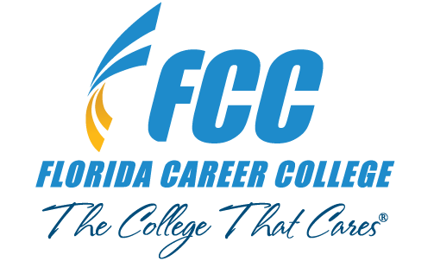
AND

OR
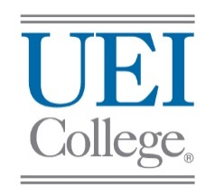

- ACCREDITATION: REMOVE RED STRIKE THROUGH AND ADD YELLOW HIGHLIGHT
Florida Career College is institutionally accredited by the Accrediting Council of Independent Colleges & Schools (ACICS) in Boynton Beach, Tampa, Hialeah, Jacksonville, Kendall, Lauderdale Lakes, Margate, Miami, Pembroke Pines and West Palm Beach.

FCC â€“ – Anthem College in Orlando, FL is institutionally accredited by the Accrediting Council of Independent Colleges & Schools (ACICS).

UEI College in Houston, TX is institutionally accredited by the Accrediting Council of Independent Colleges & Schools (ACICS).

UEI College in Phoenix, AZ is institutionally accredited by the Accrediting Council of Independent Colleges & Schools (ACICS).

- DISCLOSURE: REMOVE RED STRIKE THROUGH AND ADD YELLOW HIGHLIGHT
For more information about our graduation rates, the median debt of students who completed the program, and other important information, please visit our website at careercollege.edu/disclosures

Disclosure: http://anthem.edu/disclosures/

- TCPA REGULATIONS:
  - All forms must include the following text just below the submit button:
    - Clicking the button above constitutes your express written consent, without obligation to purchase, to be contacted (including through automated means, e.g. dialing and text messaging) via telephone, mobile device (including SMS and MMS), and/or email, even if your telephone number is on a corporate, state or the National Do Not Call Registry, and you agree to our terms of use and privacy policy.

- Notes:

