Required Add = Red
Optional Add = Blue
Already Added = Green

Miami-Jacobs Career College (MJCC) – Compliance Sheet

Vendor:
URL:

- SCHOOL NAME: Miami-Jacobs Career College (MJCC)

- LOGO:
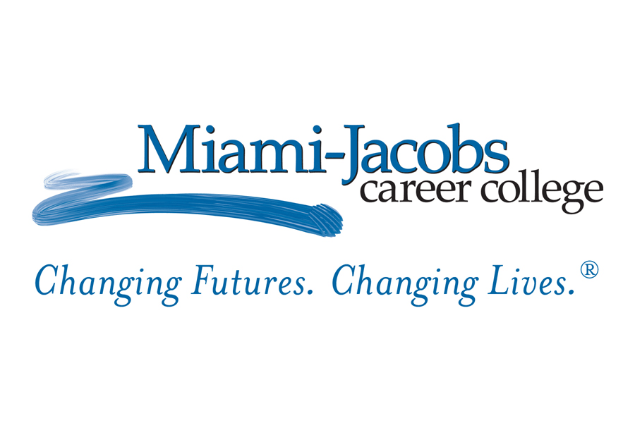
- FIELDS
  - First Name
  - Last Name
  - Email
  - Street Address
  - City
  - State
  - Country
  - Zip Code
  - Primary Phone
  - Alternate Phone
  - Year of High School Graduation
  - Highest Level of Education Completed
    - High School Diploma
    - GED
    - College Bachelor's
    - College Master's
    - College Associates
    - Incomplete HS Diploma
    - College Doctorate
    - Some College Credits
  - Program of Interest
  - Learning Location Preference
    - Online
    - Campus
    - Both
  - Birth Year
  - Ideal Start Month
    - January
    - February
    - March
    - April
    - May
    - June
    - July
    - August
    - September
    - October
    - November
    - December
  - Military Status
    - Not Applicable
    - Active Duty
    - Inactive
    - Retired

- LOCATION:
  - Miami Jacobs Specific: With five convenient locations throughout Ohio and a multitude of programs and degrees in growing fields, Miami-Jacobs Career College makes it easy to find the right fit for you.
    - Miami-Jacobs Career College Columbus is conveniently located at 150 East Gay Street.
    - Miami-Jacobs Career College Dayton is conveniently located at 401 East 3rd Street.
    - Miami-Jacobs Career College Independence is conveniently located at 6400 Rockside Road.
    - Miami-Jacobs Career College Springboro is located at 875 West Central Avenue.
    - Miami-Jacobs Career College Troy is conveniently located at 865 West Market.

- PROGRAMS:
  - Miami-Jacobs Cleveland/ Independence
      - Cosmetology - Diploma
      - Criminal Justice - Associate of Applied Business
      - Electronic Health Records- Associate of Applied Science
      - Esthetics - Diploma
      - Management - Associate of Applied Business
      - Massage Therapy - Diploma
      - Medical Assisting - Associate of Applied Science
      - Paralegal - Associate of Applied Business
  - Miami-Jacobs Columbus
      - Accounting - Associate of Applied Business
      - Business Administration - Associate of Applied Business
      - Criminal Justice - Associate of Applied Business
      - Dental Assisting - Diploma
      - Electronic Health Records - Associate of Applied Science
      - Massage Therapy - Diploma
      - Medical Assisting - Associate of Applied Science
      - Medical Billing and Coding - Diploma
      - Paralegal - Associate of Applied Business
      - Surgical Technology - Associate of Applied Science
  - Miami-Jacobs Dayton
      - Business Administration - Associate of Applied Business
      - Criminal Justice - Associate of Applied Business
      - Electronic Health Records - Associate of Applied Science
      - Massage Therapy - Diploma
      - Medical Assisting - Associate of Applied Science
      - Medical Billing and Coding – Diploma
      - Surgical Technology - Associate of Applied Science
  - Miami-Jacobs Online Programs
      - Business Administration – Associate of Applied Business
      - Criminal Justice – Associate of Applied Business
      - Electronic Health Records – Associate of Applied Science
      - Paralegal – Associate of Applied Business
  - Miami-Jacobs Springboro
      - Business Administration - Associate of Applied Business
      - Cosmetology - Diploma
      - Dental Assisting - Associate of Applied Science
      - Electronic Health Records - Associate of Applied Science
      - Esthetics - Diploma
      - Massage Therapy - Diploma
      - Medical Assisting - Associate of Applied Science
  - Miami-Jacobs Troy
      - Automotive Technology - Associate of Applied Science
      - Automotive Technology - Diploma
      - Cosmetology - Diploma
      - Esthetics - Diploma
      - Massage Therapy - Diploma
      - Medical Assisting - Associate of Applied Science
      - Veterinary Technology - Associate of Applied Science

- CONTENT:

  - HEADLINE OPTION:
    - Start your future now!
    - A new career is closer than you think!
    - Miami-Jacobs Career College (MJCC) can help get you from here to a new career!

  - BRAND COPY:

Miami-Jacobs Career College (MJCC) has a history of helping students succeed through hands-on education and career training. Our faculty and staff work to ensure that when you’ve completed your program, you’re truly ready to begin your career.

Miami-Jacobs Career College (MJCC) will help you choose your ideal career before you get started and assist with real-world employment after you’re done with school. We have a wide range of resources to help you every step of the way.

In today’s world, it makes sense to spend less time in the classroom, and more time earning a salary. Miami-Jacobs Career College (MJCC) can help you start your new career in as little as 18-24 months.

If you’re worried that you can’t afford an education, think again. Financial aid is available to those who qualify. We will work with you to explore the financial aid options available to help you complete your degree.

The path to a bright future and a new career is easy – complete the form to learn more about Miami-Jacobs Career College (MJCC) now!

  - BRAND HISTORY:
Miami-Jacobs Career College (MJCC)
Columbus, OH
Dayton, OH
Independence, OH
Springboro, OH
Troy, OH

Miami-Jacobs Career College began as the product of a merger between the Miami Commercial School (founded in 1860 by Edwin D. Babbitt) and the Jacobs Business College. The two schools pioneered business education in the city of Dayton, Ohio, and, under the leadership of A.D.Wilt (Miami Commercial School) and H.L. Jacobs (Jacobs Business College) merged in 1916 to form Miami-Jacobs.
In December 2003, Miami-Jacobs Career College was acquired by the company now known as Delta Career Education Corporation, a Delaware Corporation approved to do business in the State of Ohio. In 2005, Miami-Jacobs Career College opened its first additional location in Springboro, Ohio, and in 2007, the Troy, Ohio, location opened.
In 2012, Miami-Jacobs Career College and the Academy of Court Reporting merged with the McCann School of Business & Technology whose main campus is in Pottsville, PA. The Pottsville school became the main campus for all locations, but all Miami-Jacobs schools retained their name.

Request more information now!

Programs may vary by campus.

DEL.GEN.06351.D.000

  - MILITARY FRIENDLY:
    - Miami-Jacobs Career College (MJCC) is proud to be recognized as a 2016 Military Friendly School. Learn more here: https://militaryfriendly.com/2016schools/
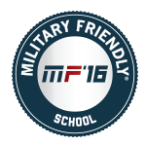

- TCPA REGULATIONS:
  - All forms must include the following text:
    - I authorize Miami-Jacobs Career College to use automated technology and prerecorded messages to call and text me about educational services it offers at the phone number I have provided above. I understand that I am not required to provide this consent to purchase any goods or services from Miami-Jacobs Career College.
  - CONSENT CHECKBOX

- NOTES:

