Required Add = Red
Optional Add = Blue
Already Added = Green

Miller-Motte Technical College Online Programs – Compliance Sheet

Vendor:
URL:
- SCHOOL NAME: Miller-Motte Technical College Online Programs

- LOGO:
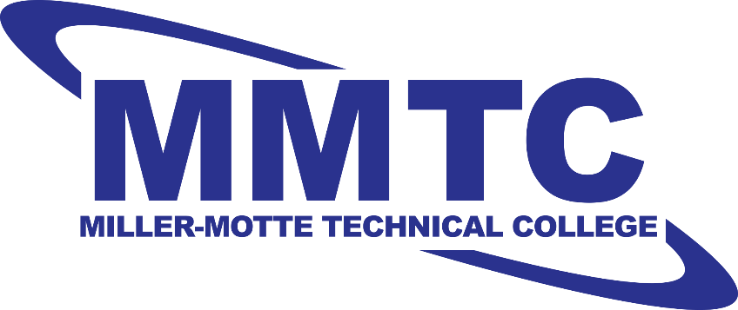

- FIELDS
  - First Name
  - Last Name
  - Email
  - Street Address
  - City
  - State
  - Country
  - Zip Code
  - Primary Phone
  - Alternate Phone
  - Year of High School Graduation
  - Highest Level of Education Completed
    - High School Diploma
    - GED
    - College Bachelor's
    - College Master's
    - College Associates
    - Incomplete HS Diploma
    - College Doctorate
    - Some College Credits
  - Program of Interest
  - Learning Location Preference
    - Online
    - Campus
    - Both
  - Birth Year
  - Ideal Start Month
    - January
    - February
    - March
    - April
    - May
    - June
    - July
    - August
    - September
    - October
    - November
    - December
  - Military Status
    - Not Applicable
    - Active Duty
    - Inactive
    - Retired
    - Military Spouse

- PROGRAMS:
  - Miller-Motte Technical College Online Programs
      - Business Administration - Associate of Applied Science
      - Criminal Justice - Associate of Applied Science
      - Medical Billing and Coding - Certificate
      - Paralegal - Associate of Applied Science

- CONTENT:

  - HEADLINE OPTION:
    - Start your future now!
    - A new career is closer than you think!
    - Miller-Motte Technical College online programs can help get you from here to a new career!

  - BRAND COPY:
Miller-Motte Technical College online programs help students succeed through hands-on education and career training. Our faculty and staff work to ensure that when you’ve completed your program, you’re truly ready to begin your career.

Miller-Motte Technical College online programs will help you choose your ideal career before you get started and assist with real-world employment after you’re done with school. We have a wide range of resources to help you every step of the way.

In today’s world, it makes sense to spend less time in the classroom, and more time earning a salary. Miller-Motte Technical College online programs can help you start your new career in as little as four weeks to two years.

If you’re worried that you can’t afford an education, think again. Financial aid may be available to those who qualify. We will work with you to explore the financial aid options available to help you complete your degree.

The path to a bright future and a new career is easy. Complete the form to learn more about Miller-Motte Technical College online programs now!

Request more information now!

Programs may vary.

DEL.GEN.06351.D.000

- TCPA REGULATIONS:
  - All forms must include the following text:
    - ​​Clicking the “Request Info” button below constitutes your express written consent to be called, emailed, and/or texted by Miller-Motte Technical College at the number/email you provided, regarding furthering your education. You understand that these calls/emails may be generated using an automated technology.
  - CONSENT CHECKBOX

- DISCLOSURE:
  - For important information about the educational debt, earnings, and completion rates of students who attended this program please visit: http://disclosure.millermotte.edu/default.aspx

- ACCREDITATION:
  - Platt College located in Tulsa, Oklahoma and Platt College branch campuses have been approved by the State of Oklahoma to participate in the National Council for State Authorization Reciprocity Agreements (NC-SARA). NC-SARA is a voluntary, regional approach to state oversight of post-secondary distance education. As a branch of Platt College located in Tulsa, Oklahoma, Miller-Motte College - Wilmington is also approved by NC-SARA.
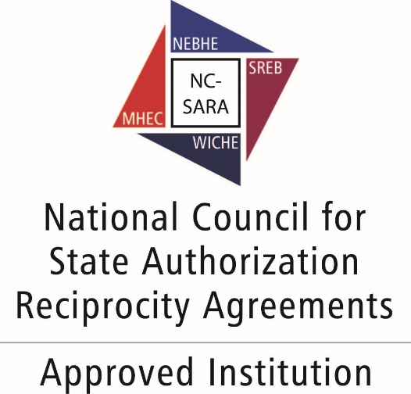

- NOTES:

